AWS Task-4
· Launch Linux & Windows EC2 instances
· Install a web server on each
· Create and attach a 5-GB EBS volume
· Take a snapshot
· Create a new EBS volume from the snapshot
PART 1: Launch EC2 Instances
A. Launch a Linux EC2 Instance (Amazon Linux)
Step 1: Open EC2 Dashboard
Log in to AWS Console
Go to Services → EC2
Click Launch Instance

Step 2: Choose AMI
Select Amazon Linux 2023 AMI

Step 3: Choose Instance Type
Select t2.micro (Free Tier eligible)

Step 4: Key Pair
Select an existing key pair or
Create a new key pair and download it

Step 5: Network Settings

Allow:
SSH (22) – My IP
HTTP (80) – Anywhere
Step 6: Storage
Keep default root volume

Step 7: Launch
Click Launch Instance
B. Launch a Windows EC2 Instance
Repeat the same steps as Linux, but:
AMI
Select Microsoft Windows Server 2019 or 2022 Base

Security Group
Allow:
RDP (3389) – My IP
HTTP (80) – Anywhere

Launch the instance.

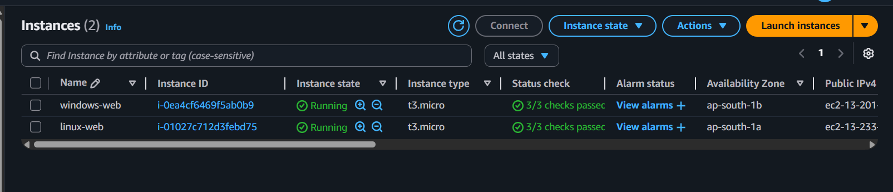
PART 2: Install Web Server
Update Package List
sudo apt update
· Updates the list of available software packages
· Always do this before installing anything
Install Apache Web Server
sudo apt install apache2 -y
installs Apache HTTP Server
-y automatically answers “yes” to prompts
Start Apache Service
sudo systemctl start apache2
Enable Apache at Boot
sudo systemctl enable apache2
Check Apache Status
sudo systemctl status apache2
You should see:
Active: active (running)
Allow HTTP in Firewall (Usually optional on EC2)
sudo ufw allow 'Apache'
On AWS EC2, Security Group rules are more important than UFW.
Make sure:

Port 80 (HTTP) Allowed in EC2 Security Group
Test Apache in Browser
Open your browser and go to:
Linux web server
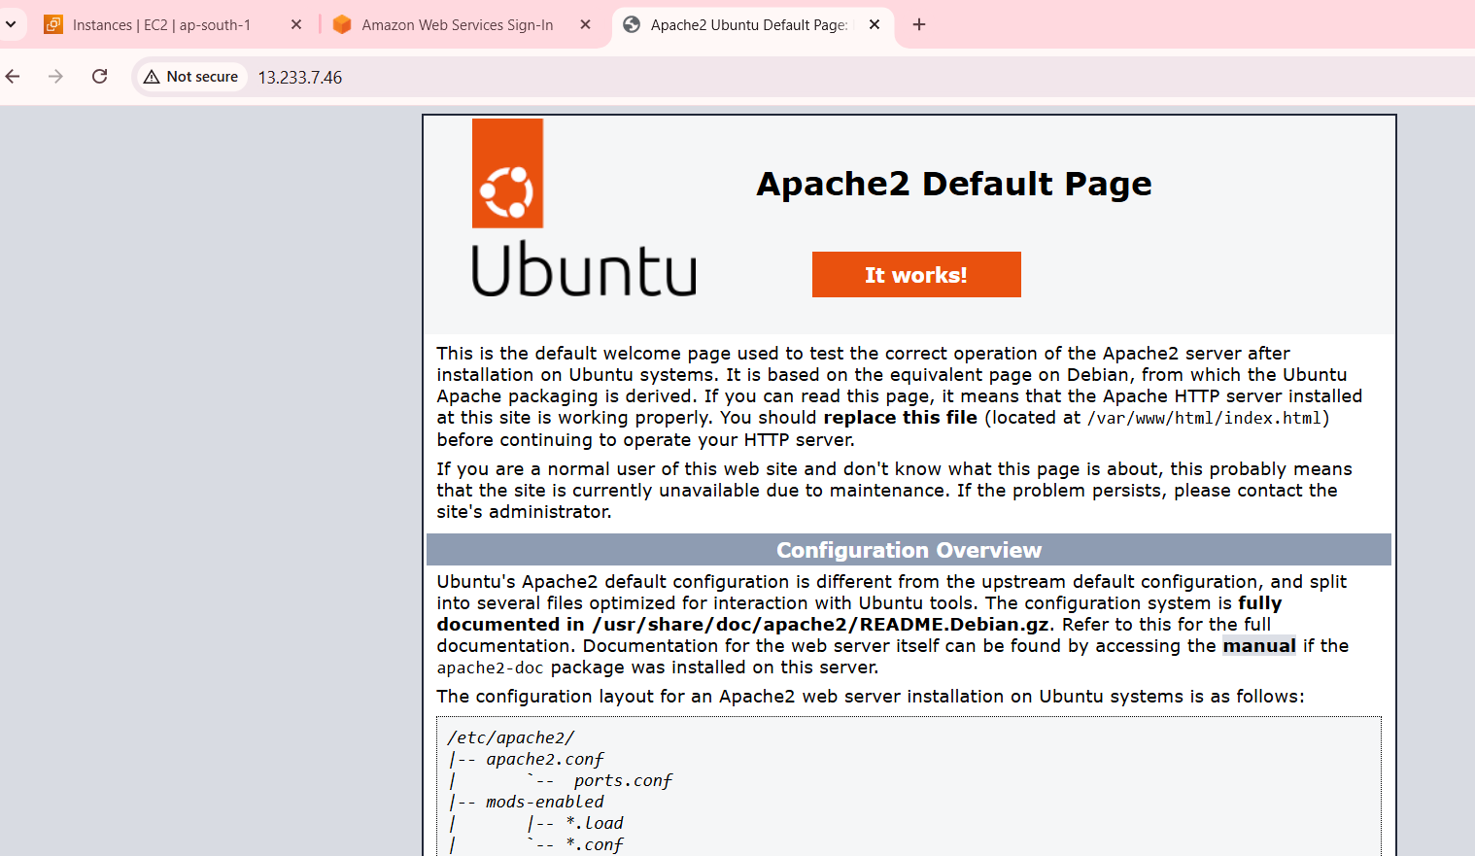

Windows web server
B. Install Web Server on Windows (IIS)
Step 1: Connect via RDP

Get Administrator password (using key pair)

Connect using Remote Desktop

Step 2: Install IIS

Open Server Manager

Click Add Roles and Features
Select Web Server (IIS)
Click Install

Step 3: Test

Open browser http://<Windows-Public-IP>

IIS default page should appear

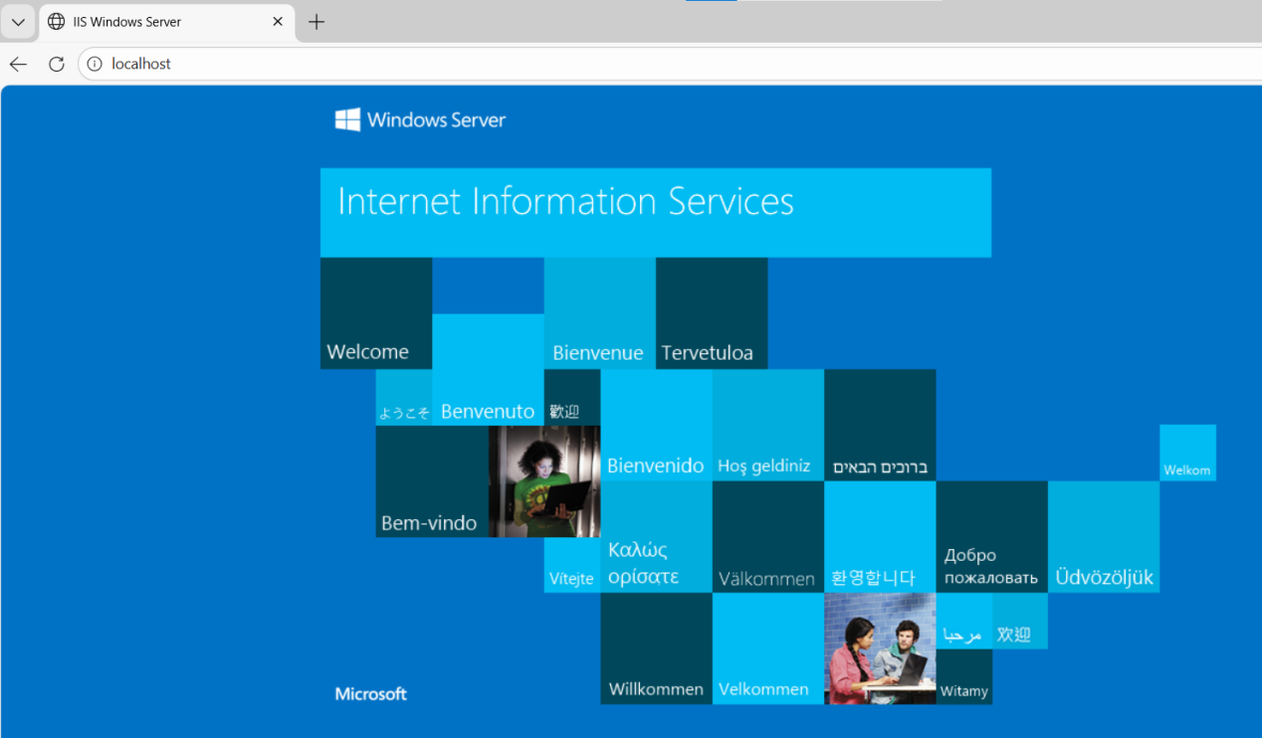

PART 3: Create a 5-GB EBS Volume
Step 1: Go to EBS
EC2 Dashboard → Elastic Block Store → Volumes
Click Create Volume

Step 2: Volume Settings
Size: 5 GiB
Volume Type: gp3
Availability Zone: SAME as EC2 instance
Click Create Volume
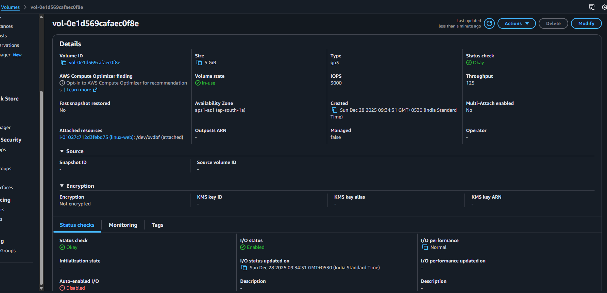

PART 4: Attach EBS Volume to EC2
A. Attach to Linux Instance

Select the volume
Click Actions → Attach Volume
Choose Linux EC2 instance
Device name: /dev/xvdf
Click Attach
lsblk
NAME MAJ:MIN RM SIZE RO TYPE MOUNTPOINT
nvme0n1 259:0 0 8G 0 disk
├─nvme0n1p1 259:1 0 8G 0 part /
nvme1n1 259:2 0 5G 0 disk
Your new 5-GB EBS volume is nvme1n1
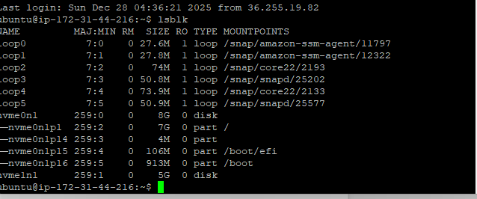
sudo mkfs -t ext4 /dev/nvme1n1
sudo mkdir /data
sudo mount /dev/nvme1n1 /data
df -h
You should see:
/dev/nvme1n1 4.9G ... /data
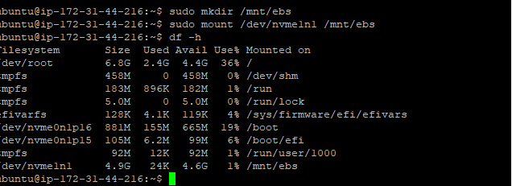
PART 5: Create Snapshot of EBS Volume
Step 1: Create Snapshot

EC2 Dashboard → Volumes
Select the 5-GB volume
Click Actions → Create Snapshot
Add description
Click Create Snapshot
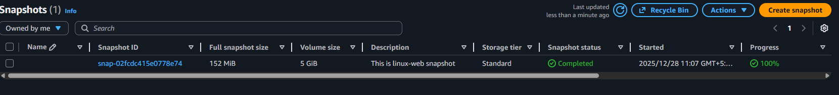
PART 6: Create New EBS Volume from Snapshot
Step 1: Go to Snapshots
EC2 → Snapshots

Step 2: Create Volume
Select the snapshot
Click Actions → Create Volume

Choose:
Same Availability Zone
Volume type: gp3

Click Create Volume
New EBS volume is now created from snapshot
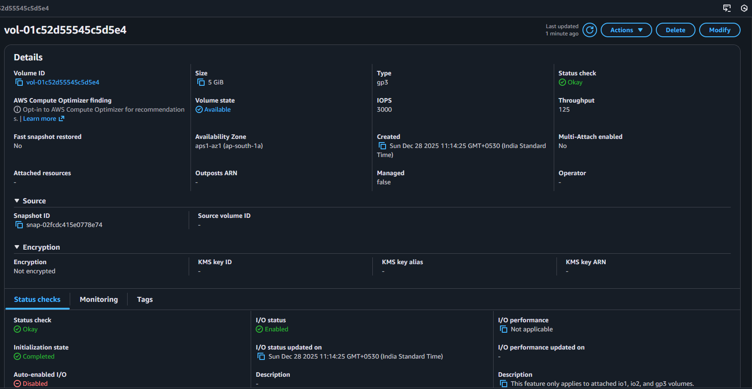
FINAL FLOW SUMMARY
Launch Linux & Windows EC2
Install Apache (Linux) & IIS (Windows)
Create 5-GB EBS volume
Attach volume to EC2
Format & mount volume
Take snapshot
Create new volume from snapshot

